Stock Donation and Mutual Fund Form for:
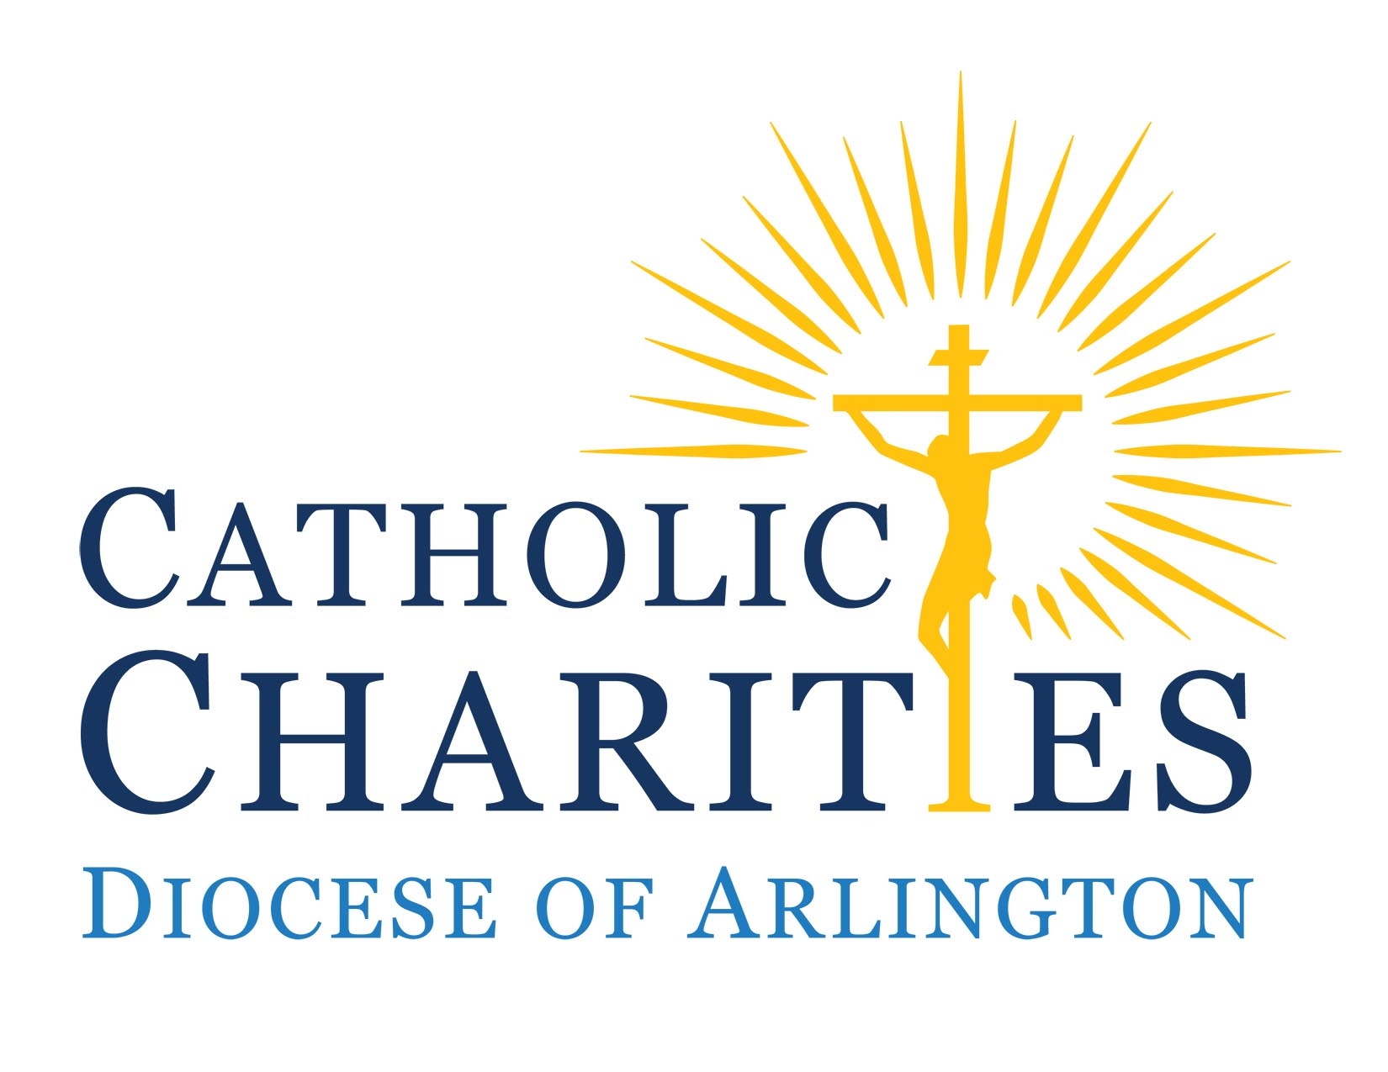
Please use this form to alert us that you are initiating a transfer of a stock or mutual fund to our account. You will also need to send a separate letter to your broker, detailing your donation of stock.

Ms. Meseret Wolde FAX: (703) 528-3057
c/o Ms. Chris Farmer Phone: (703) 841-3896
Catholic Charities, Diocese of Arlington Email: christine.farmer@arlingtondiocese.org
200 North Glebe Road, Suite 811
Arlington, VA 22203

Dear Mr. Zimmermann:

Please accept this as notification that I am donating the following shares of stock/mutual fund, currently held in my account at:

Name of Bank or Brokerage Firm: _____________________________________

Shares of: ______________________________________________ (e.g. IBM)

Stock/Mutual Fund Symbol: ____________________(e.g. MSFT for Microsoft Corp.) Number of Shares: ________________

In separate writing, I will instruct the agent who administers my account to transfer these shares to:

Catholic Charities, Diocese of Arlington A/C# PQ1-609219, DTC #0443 Pershing, LLC

Please note if this gift to Catholic Charities is designated to a particular program area: ________________________________________________________________________________________

If I hold actual certificates, I will call the representative of McLaughlin Ryder Investments listed below for delivery instructions.

Signature of Donor(s): Date

Printed Name of Donor(s)

Address:

City, State, Zip:

Phone Number: ( ) Email:

Please give a copy of this form and your separate instruction letter to your advisor and send copies of this form to:
- McLaughlin Ryder Investments, Inc. (address/FAX listed below) and
- Ms. Meseret Wolde, Controller (address/ FAX listed above)

For Communication to Catholic Charities, Diocese of Arlington:
Please use the contact information at the top of this page.

For Communication to McLaughlin Ryder Investments:

McLaughlin Ryder Investments, Inc. FAX: (703) 684-9224
Attention: Ms. Mary Reed Phone: (703) 684-9222 or
1421 Prince Street, Suite 200 Toll-free: (866) 684-9222
Alexandria, VA 22314 Email: mreed@mclaughlinryder.com

